**Methodology**

**1. Return Prediction Process**

The prediction process starts with assigning the basic probability of each factor. We have collected the 5 years historical data of those four factors of 31 different companies present in Bombay Stock Exchange (BSE). Now, for assigning the basic probability we have to calculate the Price to Book value, Price to Earnings ratio, long term debt equity ratio, Dividend Yield and Price to Sales ratio.

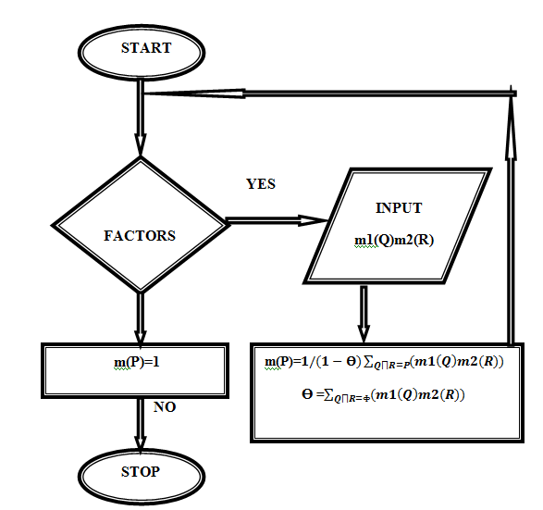

Figure1.1 Flowchart of Prediction Process

Formulas for calculating the ratio from the historical data are given bellow:

a) Price to Book Value:

P/B= Closing Price/Book Value

If P/B is less than 1 then the company is earning very less even negative return.

b) Price to Sales Ratio:

P/S=Market Capital/Total Sales or Revenue

If P/S ratio is less than 1 then the company is earning high.

c) Price to Earnings Ratio:

P/E=Stock Price per Share/Earning per Share

If P/E ratio of a company is high means that company earn higher in future.

d) Dividend Yield:

If a company paying less in dividends relative to its price that means the company may be having some problem.

e) Long-Term Debt Equity Ratio:

LTDER=Long-Term Debt/(Preferred Stock + Common Stock)

Generally, higher ratio means more Risky because that has more liabilities and less equity.

# 3.4.2 Basic Probability Assignment This is very important and first step in evidence theory. It is still an open issue, various researcher are working on it. In this we assign the basic probability of return good or poor based on the ratio of each factor with Semi variance to Risk ratio. So we use the existing sample data to assign the degree of belief.

# Initially, we assign the basic probability of each factor for a single company (Bajaj Auto).

Table3.1. Basic Probability assignments of each factor

|  |  |  |  |
| --- | --- | --- | --- |
| **No.** | **Factors** | **Return** | **Basic Probability assignment** |
| 1 | Price to EPS(earn per share)good | RGood  RPoor | 0.4  0.5 |
| 2 | P rice to Book value good | RGood  RPoor | 0.5  0.1 |
| 3 | LTDER(long term debt equity  ratio)good | RGood  RPoor | 0.7  0.2 |
| 4 | Div. Yield | RGood  RPoor | 0.8  0.1 |

**For factor 1 (Price to Earnings ratio)**

m1(Return_Good)=0.4

m1(Return_Poor)=0.5

m1(ϴ)=1-(0.4+0.5)=0.1

**For factor 2( Price to Book value_good)**

m2(Return_Good)=0.5

m2(Return_Poor)=0.1

m2**(**ϴ)=1-(0.5+0.1)=0.4

Now combine factor1 and factor 2

Table3.2. Combine factor1 with factor2

|  |  |  |  |
| --- | --- | --- | --- |
|  | m1(Return_Good)=0.4 | m1(Return_Poor)=0.5 | m1(ϴ)=1-(0.4+0.5)=0.1 |
| m2(Return_Good)=0.5 | Return_Good=0.2 | Φ=0.25 | Return_Good=0.05 |
| m2(Return_Poor)=0.1 | Φ=0.04 | Return_Poor=0.05 | Return_Poor=0.01 |
| m2(ϴ)=0.4 | Return_Good=0.16 | Return_Poor=0.20 | ϴ=0.04 |

# m3(Return_Good)= (0.2+0.05+0.16)/1-(0.25+0.04)=0.5774

# m3(Return_Poor)=(0.05+0.01+0.20)/0.71=0.3661

# m3(ϴ)=0.04/0.71=0.05

**For factor 3(LTDER_good)**

m4(Return_Good)=0.7

m4(Return_Poor)=0.2

m4**(**ϴ)=1-(0.7+0.2)=0.1

Now combine factor1, factor 2 and factor3

Table3.3. Combine factor1, 2 and 3

|  |  |  |  |
| --- | --- | --- | --- |
|  | m3(Return_Good)=0.5774 | m3(Return_Poor)=0.3661 | m3(ϴ)=1-(0.7+0.2)=0.05 |
| m4(Return_Good)=0.7 | Return_Good=0.4041 | Φ=0.25627 | Return_Good=0.035 |
| m4(Return_Poor)=0.2 | Φ=0.115 | Return_Poor=0.0732 | Return_Poor=0.01 |
| m4(ϴ)=0.1 | Return_Good=0.0577 | Return_Poor=0.0366 | ϴ=0.005 |

# m5(Return_Good)=(0.4041+0.35+0.0577)/1-(0.2562+0.115)=0.79016

# m5(Return_Poor)=(0.0732+0.01+0.0366)/0.6287=0.1905

# m5(ϴ)=0.005/0.6287=0.00795

**For factor 4(Div. Yield_good)**

m6(Return_Good)=0.8

m6(Return_Poor)=0.1

m6**(**ϴ)=1-(0.8+0.1)=0.1

Now combine factor1, factor 2, factor3 and factor4

Table3.4. Combine factor1, 2, 3 and 4

|  |  |  |  |
| --- | --- | --- | --- |
|  | m5(Return_Good)=0.79 | m5(Return_Poor)=0.19 | m5(ϴ)=0.0079 |
| m6(Return_Good)=0.8 | Return_Good=0.63 | Φ=0.152 | Return_Good=0.006 |
| m6(Return_Poor)=0.1 | Φ=0.079 | Return_Poor=0.019 | Return_Poor=0.0007 |
| m6(ϴ)=0.1 | Return_Good=0.079 | Return_Poor=0.019 | ϴ=0.0007 |

**m7(Return_Good)=(0.63+0.006+0.079)/1-(0.152+0.079)=0.9297**

m7(Return_Poor)=(0.019+0.019+0.0007)/0.769=0.05

m7(ϴ)=0.0007/0.769=0.00092

The value of m7 (Return_good) is more than 0.5. So we can say that the performance or the return of Bajaj Auto will be good in future. Similarly, we can apply this theory for each company to evaluate the performance and also we can give a rank of each company present in BSE.

1. **Possibilistic Sharp Ratio**
2. **Skewness**
3. **Value at Risk**
4. **Return**